ILMORA: How It Works, A to Z
16 October 2026 · Mohammednur Sukyan
ILMORA, the branded Digital Madrasa Mobile Application, runs a madrasa and supports Quran learning in one app, for owners, teachers, parents and pupils, with each madrasa's records kept private.

Who uses ILMORA
Five roles share one system; the database decides what each may see and do.
Role | What they do | Where
Madrasa owner | Registers the madrasa, admits pupils, manages classes, staff and fees, approves parents | Android app
Teacher | Takes attendance, records memorisation, reviews recitations, teaches live, messages parents | Android app
Parent | Follows their own children, pays fees, messages teachers, sponsors pupils | Android app, or USSD on a basic phone
Pupil | Follows the hifz plan, records recitations, practises, earns badges | Android app
Platform administrator | Oversees every madrasa, their impact and the audit log | Website (admin console)

Every user chooses English, Kiswahili, Somali or Arabic; Arabic is shown right to left. The website is https://https-ilmora-expo-app.expo.app.

How it fits together
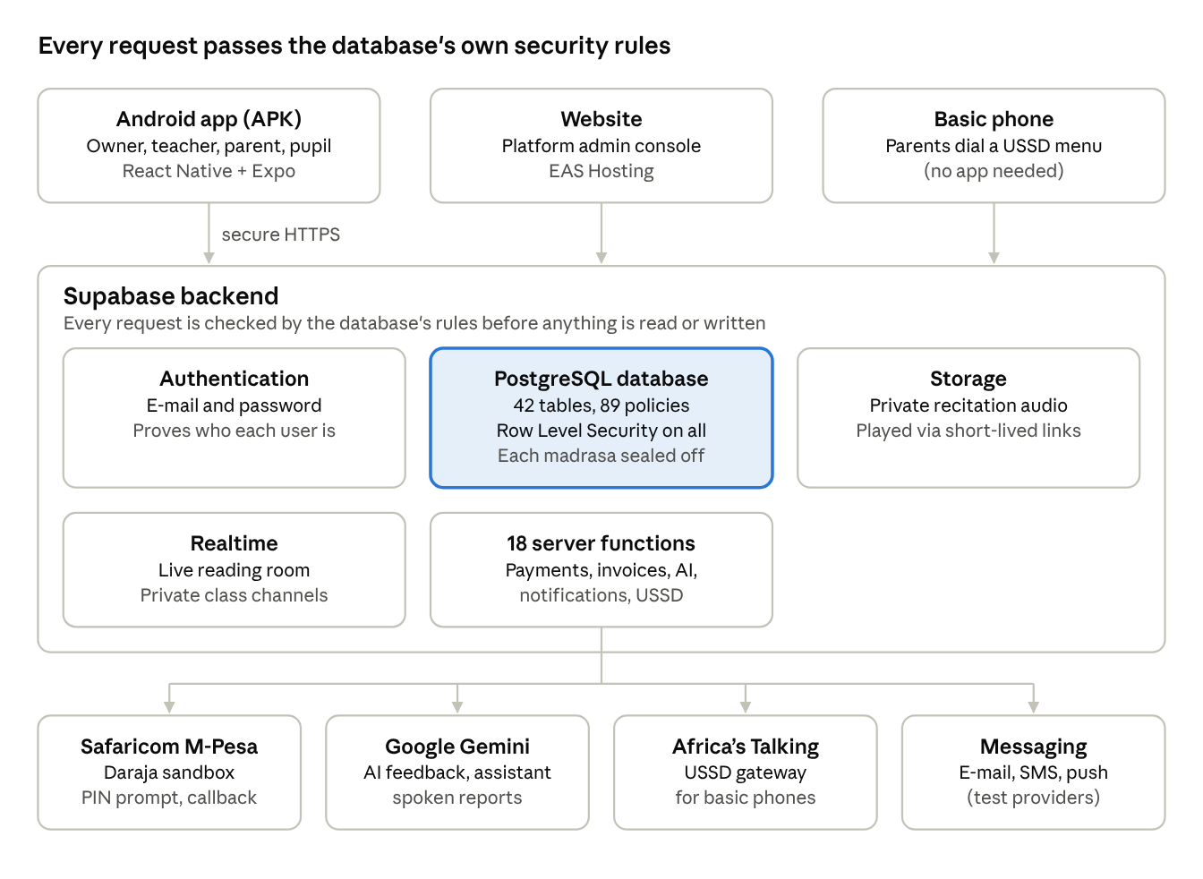
Figure 1. ILMORA architecture: three ways in, one backend, four outside services
The app, website and USSD all reach one Supabase backend, where the database checks every request; only the server functions talk to M-Pesa, Gemini, Africa's Talking and the messaging providers, so secret keys never sit on a phone.

Setting up a madrasa (owner)
An owner goes from registration to a working madrasa in six steps.
1. Register. Tap Register my madrasa and enter the madrasa's name, county, town and your details. The madrasa gets its own private space and a 30-day free trial, then a subscription of Ksh 3,000 a month, paid in the app.
2. Create classes, for example Hifz Level 1 or Qaidah Beginners, from the Classes tab.
3. Add teachers in More → Staff by e-mail. There is no invitation e-mail: the teacher opens the app, taps Forgot password with that address, sets a password and signs in.
4. Admit pupils in Students → Add: name, date of birth, gender and class. The system issues the admission number itself (DM-2026-0001 style) and creates the pupil's login; nobody can type the number in.
5. Set fees. Create a fee structure (for example Term 1 tuition, Ksh 4,500), then issue invoices to the whole madrasa, one class or one pupil. Each invoice gets a number such as INV-2026-0003.
6. Approve parents. A parent's request to link to a child appears under Parent requests; the parent sees nothing about the child until the madrasa approves.
The owner's dashboard shows the Hijri date, pupils, this week's attendance, fees collected and outstanding, recitations to review, parent requests and today's classes.

A teacher's day
The teacher takes attendance, records progress and reviews recitations; the teacher's mark is always final.
1. Take attendance.
- Manually: Classes → class → Mark attendance → Present, Absent, Late or Excused.
- By QR: the teacher's phone shows a code that changes every 30 seconds, and pupils scan it. An old or photographed code is refused, and the server checks the class and the time.
- Offline: with no internet the register is saved on the phone and sent automatically when the connection returns; a banner says so.
2. Record memorisation surah by surah (learning, memorised, revising, mastered). The app works out the juz completed and what is due for revision.
3. Review recitations under Recitations to review: play the pupil's recording, see the AI's provisional feedback if the parent allowed AI, tap Compare with a master reciter to hear Al-Husary, Alafasy or Al-Minshawy recite the same ayahs, then give a score and a comment.
4. Assignments, grades and certificates. Set and mark written work, and award certificates with a QR code anyone can scan to verify, or ijazah certificates that carry the teacher's sanad.
5. See the class at a glance. Co-pilot insights show who is stuck, falling behind or improving this week; the mistake map shows which tajweed rules the class gets wrong most.
6. Teach live. Schedule a session in More → Lessons with a Google Meet or Zoom link, and the class and its parents get a notice. In the live reading room pupils raise hands, the teacher picks a reader, the ayah lights up on every phone, and the teacher marks the reading.
7. Video library. Add YouTube Quran or tajweed videos for one class or all classes.
8. Messages. Reply to the parents of children the teacher teaches.

A pupil's day
The pupil's dashboard says what to revise today and keeps practice motivating.
1. Sign in. The dashboard greets the pupil with the Hijri date and shows:
- Today's revision: the passages due.
- The daily hifz plan: Sabaq (new lesson), Sabqi (recent revision) and Manzil (old revision).
- Streaks and badges: days in a row, best run, weeks in a row, and 11 badges such as First surah, Juz ʿAmma and 7-day streak. A New badge banner celebrates each new one once.
- Juz memorised, attendance and assignments.
2. Record a recitation. Choose the surah and ayahs, record, listen back and submit. The audio is stored privately; with a parent's consent the AI gives provisional tajweed feedback, and without it nothing is sent to the AI.
3. Recite along. Words light up as the pupil recites; it is practice only, never marked.
4. Learn. Watch teacher-chosen videos, read the Quran text offline, and ask the assistant.
5. In class. Scan the attendance QR code, and join the live reading room during a live lesson.

A parent's experience
A parent sees only their own children, and only after the madrasa approves the link.
1. Sign up with name, e-mail, phone and password, and give consent under the Kenya Data Protection Act 2019.
2. Link your child with the admission number and date of birth. Once the madrasa approves, the child appears; a parent with several children switches between them.
3. Follow the child: attendance, memorisation, grades, reviewed recitations with the teacher's comments, certificates, the hifz plan, and streaks and badges.
4. Listen to a spoken report of the child's progress in Kiswahili, Somali, English or Arabic.
5. Turn AI feedback on or off for the child. It stays off until the parent allows it.
6. Pay fees by M-Pesa or card (see Paying fees).
7. Message the teacher. A parent can write only to the teachers of their own child.
8. Inbox and notifications: announcements, live-session notices, reviews and fees, by push, e-mail or SMS according to the parent's preferences.
9. Sponsor a pupil (sadaqah). Pay towards another child's fees, anonymous in both directions.
10. Basic phone? Use USSD. Dial the code to see your own children's attendance and fees; the phone number reaches only that parent's children.

Paying fees
The server, not the phone, decides how much is paid, and each payment is settled exactly once.
1. The owner issues invoices (INV-2026-0003 style); they appear under the parent's Fees tab.
2. The parent taps Pay now, chooses M-Pesa and enters a Safaricom number.
3. The app sends only which invoices to pay. The server works out the amount from those invoices.
4. The server asks Safaricom (Daraja) to send an M-Pesa PIN prompt to the phone.
5. The parent enters the M-Pesa PIN.
6. Safaricom confirms to the server through a secret-checked callback, and the server marks the invoice paid once, even if the confirmation arrives twice.
7. A receipt (RCP-2026-0014 style) appears with M-Pesa's transaction code and can be shared as a PDF; the parent is notified.
If the parent cancels or lacks funds, the app shows the reason and the invoice stays due. Card payment works the same way through Paystack's hosted page, so card numbers never pass through the app.

The platform administrator
The administrator works on the website; on a phone the app says to open the console on a computer.
- Overview: active and suspended madrasas, pupils, staff, subscription revenue, fees collected and notification delivery.
- Madrasas: search every madrasa, review its standing, suspend it or schedule its deletion.
- Impact: what ILMORA has achieved across all madrasas, such as surahs memorised, attendance and recitations assessed. Each owner also sees an Impact page for their own madrasa.
- Audit log: every recorded action, newest first; it cannot be edited.

Security and privacy
The database itself enforces every rule, so even a tampered app cannot reach another madrasa's records.
- Each madrasa is sealed off: Row Level Security is forced on all 42 tables, through 89 policies.
- Roles are enforced by the database: a pupil cannot make himself an owner, and a parent cannot admit pupils.
- Parents see a child only after the madrasa approves the link.
- Recordings are private and play only through short-lived links.
- Money is protected: the server sets the amount, the M-Pesa callback is secret-checked, and each payment settles once.
- AI on a child's voice needs a parent's consent.
- Secret keys stay on the server, never in the app.
- Proof: npm run security:report runs 21 test suites against the live database and proves 145 guarantees.

Behind the scenes
- Offline: the last screens opened stay visible, and attendance marked offline is queued on the phone and sent on reconnection.
- Notifications: a server function delivers the inbox, push, e-mail and SMS according to each user's preferences.
- Backups and checks: the database is backed up every three days, and GitHub runs automatic checks on every change.
- Testing: 185 unit tests, 78 functional test cases, 21 security suites proving 145 guarantees, and 30 of 31 interface checks passed (push notifications still to be verified).
- Deployment: the Android APK is built with Expo Application Services (EAS Build) and shared directly or on WhatsApp; the website runs on EAS Hosting; the backend runs on a hosted Supabase project with 41 database migrations and 18 server functions.

Live or test mode
Most of ILMORA runs live; payments by card, e-mail and SMS are still in test mode.
Feature | Status
Accounts, attendance, memorisation, recitations and reviews, fees, messaging, badges, reading room, videos, USSD | Working on the live server
M-Pesa | Safaricom's Daraja sandbox: a real PIN prompt with test money. Real fees need a registered Paybill or Till number, with no code change
Card, e-mail and SMS | Test (mock) providers until real accounts are set up
AI feedback | Google Gemini, labelled provisional; the teacher's review decides
Video inside the app | Built but switched off (needs a paid provider); live lessons use Google Meet or Zoom links
Push notifications | Built; need a Firebase project to deliver

Try it yourself
The demo accounts all use the password Madrasa2026! and connect to the live server.
Role | Sign-in e-mail
Owner | owner@annur.example
Teacher | fatuma@annur.example
Parent | parent@example.com
Pupil | aisha.hassan@annur.example
Platform administrator | Your own account, on the website

A good order for showing it to a panel is in the project's demo run sheet (docs/demo-run-sheet.md).

